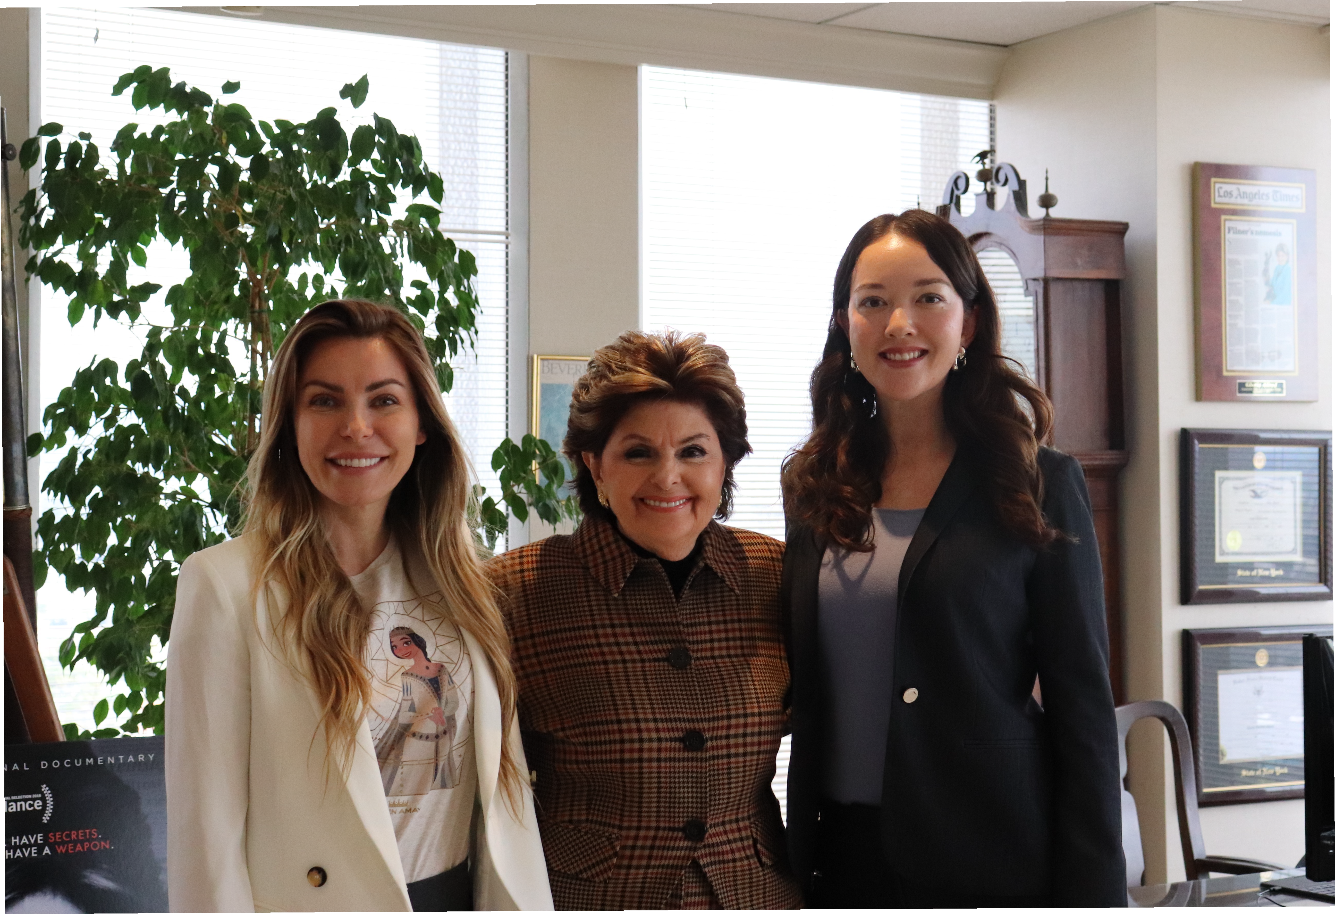

Credit: Allred, Maroko & Goldberg
Left to right: Crystal Hefner, Gloria Allred, Olivia Flechsig

